Overview Sheet 2

Date: Alex Hoganson/Nate Foss
Name: 9/24/15
Research Topic: Etch-A-Whiteboard

Illustration(s)
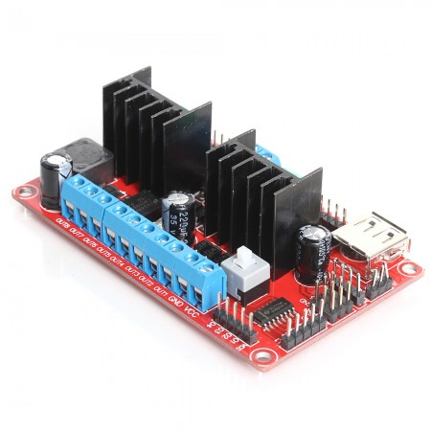

General Description
L298N is a dedicated driver ICs belonging to H-bridge IC, the output current is 2A, maximum current 4A, the maximum operating voltage of 50V, can drive inductive loads
Easily controlled by the microcontroller
You can achieve the motor forward and reverse
This module has a small, convenient control features
This module can control two-phase, three-phase motors, four phases. Supports 2-way DC motor control, 4-phase stepper motor control.

Key Features
Drive portion of the terminal supply area Vs: + 5V ~ + 30V
Drive section peak current Io: 2A
Low: -0.3V≤Vin≤1.5V
High: 2.3V≤Vin≤Vss
Maximum power consumption: 20W
The drive plate size: 90 * 54 * 28mm

Pros
Wifi
Only need to buy one chip for both motors
Less wires

Cons
More expensive
Bigger

Specifications
$ 14.49

Additional Notes
No reviews

Full APA Citation
http://www.eachbuyer.com/l298n-v3-4-channels-step-motor-powered-driver-module-wifi-car-driver-board-p369211.html?currency=USD&from=pla&gclid=CjwKEAjw-IOwBRD1wrTC27fSjFISJABUDZ17mZqF_zqR-jiUA_TQQ8_tmlSnzOw9sd99eWdKEAb-7xoCj1Dw_wcB#detail-tab2

